LOW LEVEL DOCUMENT
Spam Ham Classifier

Written by | Namrata Mishra
Last Revised Date | 19-January-2022

Contents:
1.Introduction
2.Architecture
3.Architecture Description

1.Introduction

What is HLD?

(LLD) is like detailing the HLD. It defines the actual logic for each and every component of the system. Class diagrams with all the methods and relation between classes comes under LLD. Programs specs are covered under LLD.

2.Architecture

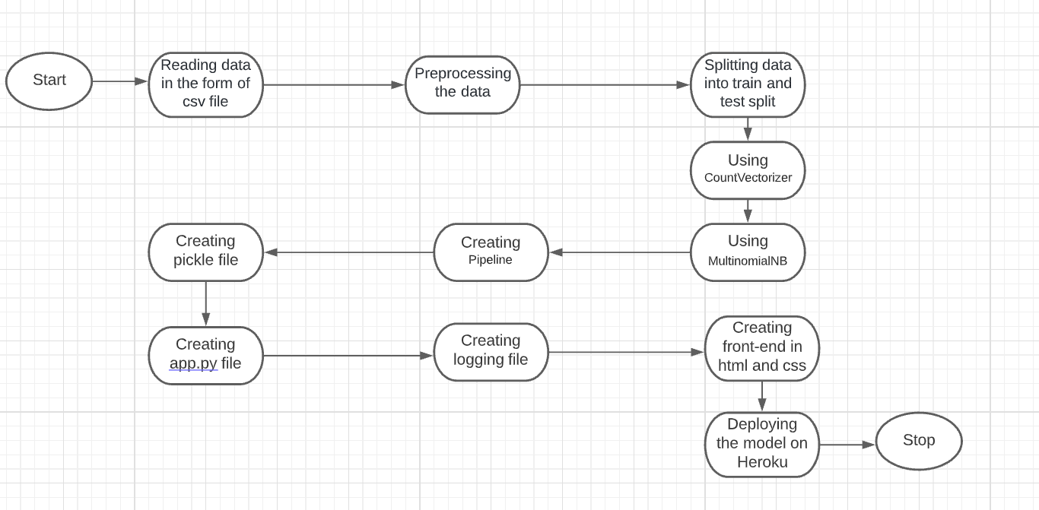

3.Architecture Description

Data Description

• A collection of 425 SMS spam messages was manually extracted from the Grumbletext Web site.

• A subset of 3,375 SMS randomly chosen ham messages of the NUS SMS Corpus (NSC), which is a dataset of about 10,000 legitimate messages collected for research at the Department of Computer Science at the National University of Singapore.

• A list of 450 SMS ham messages collected from Caroline Tag's PhD Thesis.

Export Data

Data is exported as CSV file to be used for data pre-processing and model training.

Data Pre-processing

Data Pre-processing steps we could use are Null value handling, stop words removal, punctuation removal, Tokenization, Lemmatization, CountVectorizer.

Model Building
CountVectorizer and MultinomialNB is used for model building.

CountVectorizer - CountVectorizer is a great tool provided by the scikit-learn library in Python. It is used to transform a given text into a vector on the basis of the frequency (count) of each word that occurs in the entire text.
Ex: doc=["One Cent, Two Cents, Old Cent, New Cent: All About Money"]
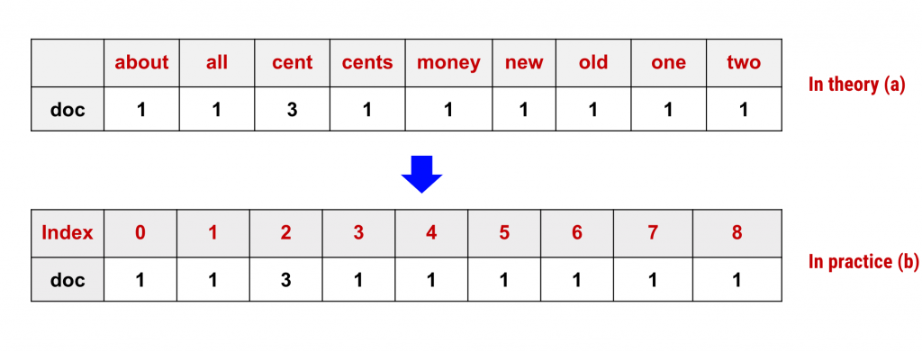

MultinomialNB - The multinomial Naive Bayes classifier is suitable for classification with discrete features (e.g., word counts for text classification). The multinomial distribution normally requires integer feature counts.

Deployment

Flask is used for deployment.

The model is deployed on Heroku.

